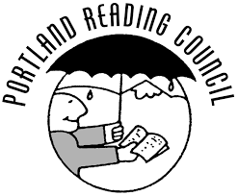
Announcing the Annual Celebrate Literacy Awards
Tell Us About an Outstanding Literacy Champion

The Portland Reading Council is seeking your nomination for an individual who demonstrates an outstanding commitment to literacy.
Nominees will be considered based on the following criteria:

Professional practice
The nominee demonstrates expertise, creativity, and innovation in promoting literacy. They use a variety of techniques and effectively address readers’ diverse needs. The nominee engages in experiences to improve his or her practice and to gain new skills and knowledge.

Contribution to literacy
The nominee engages in activities that advance literacy as well as promote a lifelong love of reading. The nominee demonstrates an impact on literacy in their community.

Attention to diversity
The nominee promotes literacy to meet the needs of all individuals, honoring diverse values, cultures, and experiences through quality interactions with readers.

 To nominate an outstanding literacy champion, please fill out the information below and create a nomination letter no more than 2-pages in 12 pt. font.
 Nomination letters must include specific examples of how your nominee meets each criteria above.
Your Information: |  |  |  | Nominee’s Information
Name |  |  | Name
School |  |  | School
Title |  |  | Title
Cell # |  |  | Cell #
Email |  |  | Email

Please send the completed form and letter by March 8, 2020 to: pennyplavala@gmail.com

✴ Eligible regions: All Multnomah and Clackamas County + Beaverton, Sherwood and Tigard-Tualatin S.D.
Winners will be honored at an awards event on May 6, 2020.
