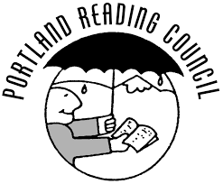
Announcing the Annual Celebrate Literacy Awards
Tell Us About an Outstanding Literacy Educator

The Portland Reading Council is seeking your nomination for an individual who demonstrates an outstanding commitment to literacy.
Nominees will be considered based on the following criteria:

Professional practice
The nominee demonstrates instructional expertise, creativity, and innovation in literacy education. They use a variety of pedagogical techniques and effectively addresses students’ diverse needs. The nominee engages in experiences to improve his or her practice and to gain new skills and knowledge.

Contribution to literacy
The nominee engages in activities that advance literacy education as well as promote a lifelong love of reading. The nominee demonstrates an impact on literacy in their community.

Attention to diversity
The nominee promotes literacy to meet the needs of all individuals, honoring diverse values, cultures, and experiences through instruction and interactions with students.

 To nominate an outstanding literacy educator, please fill out the information below and create no more than a 2-page nomination letter in 12 pt. font.
 Nomination letters must include specific examples of how your nominee meets each of the above criteria.
Your Information: |  |  |  | Nominee’s Information
Name |  |  | Name
School |  |  | School
Title |  |  | Title
Phone # |  |  | Phone #
Email |  |  | Email

Please send the completed form and letter by April 3, 2019 to: pennyplavala@gmail.com

✴ Eligible schools: All Multnomah and Clackamas County + Beaverton, Sherwood and Tigard-Tualatin
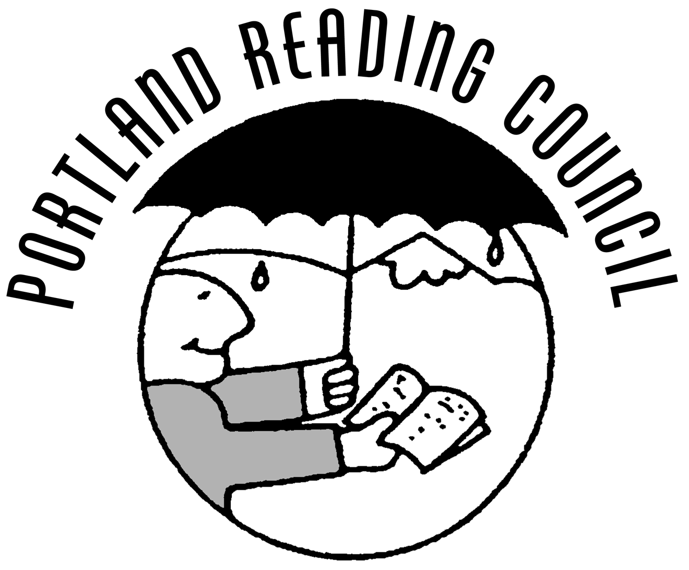
Winners will be honored at the formal evening awards event on May 8 at Parkrose M. S. in Portland

