**A Children’s Choice Award**

**Each child votes for his or her favorite book**

The award is named for Patricia Gallagher, a retired Western Oregon University professor of children’s literature, a former ORA President, and a former member of the nominating committee.

***Nominees for the 2016-2017 Award***

**About the Award**

The award was founded in 1997 as a

way to promote literacy and a love of

reading—one of the goals of the Oregon

Reading Association, a professional

organization of approximately 3,000

members.

The books are chosen by a committee of

ORA leaders, teachers, school librarians,

and public librarians.

The books must be readily available in paper,

be no more than eight years old, hold an innate

appeal to children, have quality text and

illustrations and work well as a read-aloud.

**Who May Vote?**

Oregon school children of all ages are

eligible to vote. Each child votes for his

or her own favorite. This is not a group vote.

**When to Vote**

Voting occurs between September 1,

2016 and May 1, 2017. Votes must be

reported by **May 1, 2017**.

**Where to Vote**

Voting may take place in any classroom,

school library, or public library in

the state of Oregon.

**Reporting Votes**

Report votes by email to

Mickie French:

Mickie.french@dsd2.org

Please list grade level(s) and school

Phone: 503-779-6333

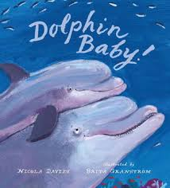 **DOLPHIN BABY**

by Nicola Davies

Illustrated by Brita Grandstrom

Candlewick Press

978-0763670481

www.nicola-davies.com

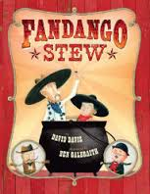

**FANDANGO STEW**

by David Davis

Illustrated by Ben Galbraith

Sterling Children’s Books

978-1454916802

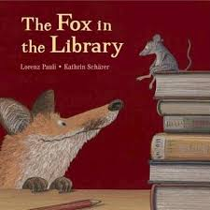**THE FOX IN THE LIBRARY**

by Lorenz Pauli

Illustrated by Kathrin Schaerer

North-South

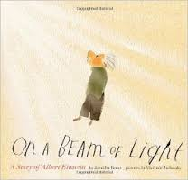**ON A BEAM OF LIGHT:**

**A STORY OF ALBERT EINSTEIN**

by Jennifer Berne

Illustrated by Vladimir Radunsky

Chronicle Books

978-1452152110

www.jenniferberne.com

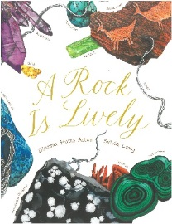

**A ROCK IS LIVELY**

by Dianna Hutts Aston

Illustrated by Silvia Long

Chronicle Books

978-1452145556

katenelms.diannahaston.com